**SECURITIES AND EXCHANGE COMMISSION**

**WASHINGTON, D.C. 20549**

**FORM 8-K**

**CURRENT REPORT**

**Pursuant to Section 13 or 15(d) of the**

**Securities Exchange Act of 1934**

**Date of report (Date of earliest event reported):  April 17, 2020**

**GEOVAX LABS, INC.**

**(Exact name of registrant as specified in its charter)**

|  |  |  |  |  |
| --- | --- | --- | --- | --- |
| **Delaware** |  | **000-52091** |  | **87-0455038** |
| **(State or other jurisdiction of**  **incorporation or organization)** |  | **(Commission File No.)** |  | **(IRS Employee Identification No.)** |

**1900 Lake Park Drive, Suite 380**

**Smyrna, Georgia 30080**

**(Address of principal executive offices) (Zip code)**

**(678) 384-7220**

**(Registrant’s telephone number, including area code)**

Check the appropriate box below if the Form 8-K filing is intended to simultaneously satisfy the filing obligation of the Registrant under any of the following provisions.

[  ] Written communications pursuant to Rule 425 under the Securities Act (17 CFR 230.425)

[  ] Soliciting material pursuant to Rule 14a-12 under the Exchange Act (17 CFR240.14a-12)

[  ] Pre-commencement communications pursuant to Rule 14d-2(b) under the Exchange Act (17 CFR 240.14d-2(b)).

[  ] Pre-commencement communications pursuant to Rule 13e-4(c) under the Exchange Act (17 CFR 240.13(e)-4(c))

Securities registered pursuant to Section 12(b) of the Act:  None

Indicate by check mark whether the Registrant is an emerging growth company as defined in Rule 405 of the Securities Act of 1933 (Section 230.405 of this chapter) or Rule 12b-2 of the Securities Exchange Act of 1934 (Section 240.12b-2 of this chapter).

Emerging growth company [  ]

If an emerging growth company, indicate by check mark if the Registrant has elected not to use the extended transition period for complying with any new or revised financial reporting standards provided pursuant to Section 13(a) of the Exchange Act. [  ]

This Form 8-K and other reports filed by GeoVax Labs, Inc. (the “Registrant”) from time to time with the Securities and Exchange Commission (collectively the “Filings”) contain forward looking statements and information that are based upon beliefs of, and information currently available to, the Registrant's management as well as estimates and assumptions made by the Registrant’s management.  When used in the Filings the words “anticipate”, “believe”, “estimate”, “expect”, “future”, “intend”, “plan” or the negative of these terms and similar expressions as they relate to the Registrant or the Registrant’s management identify forward looking statements.  Such statements reflect the current view of the Registrant with respect to future events and are subject to risks, uncertainties, assumptions and other factors relating to the Registrant’s industry, operations and results of operations and any businesses that may be acquired by the Registrant.  Should one or more of these risks or uncertainties materialize, or should the underlying assumptions prove incorrect, actual results may differ significantly from those anticipated, believed, estimated, expected, intended or planned.  Except as required by law, the Registrant does not undertake to update its forward-looking statements.

**Item 1.01            Entry into a Material Definitive Agreement**

On April 17, 2020, our wholly-owned subsidiary GeoVax, Inc., obtained a loan from First American Bank and Trust Company as “Lender” under Section 1002 of the CARES Act in the original principal amount of $170,200.00. The loan is described at Item 2.03 below above, and that description is incorporated herein by reference.

**Item 2.03            Creation of a Direct Financial Obligation or an Obligation under an Off-Balance Sheet Arrangement of a Registrant**

As noted, on April 17, 2020, our wholly-owned subsidiary GeoVax, Inc., obtained a loan from First American Bank and Trust Company as “Lender” under Section 1002 of the CARES Act in the original principal amount of $170,200.00.

The loan bears interest at the rate of one percent per annum and is due two years from April 17, 2020. No payments of principal or interest will be due until 180 days after the disbursement date. Commencing November 17, 2020, monthly payments of $9,578.16 will be due. Amounts due may be prepaid without penalty, subject in some instances to specified notice provisions. GeoVax, Inc. may apply to the Lender to have the principal amount reduced upon providing qualifying information regarding eligible expenses to the Lender. In the event of a default, the Lender may accelerate the payment of amounts due.

The description of the loan does not purport to be complete and is qualified in its entirety by reference to the full text of the Note.  The form of the Note is attached hereto as an exhibit and is incorporated herein by reference.

**Item 9.01            Financial Statements and Exhibits**

The following exhibit is filed with this Current Report:

10.1     [Form of Note dated April](https://www.sec.gov/Archives/edgar/data/832489/000143774918022697/ex_132189.htm) 17, 2020

**SIGNATURE**

Pursuant to the requirements of the Securities Exchange Act of 1934, the Registrant has duly caused this Current Report to be signed on its behalf by the undersigned hereunto duly authorized.

Dated: April 20, 2020

|  |  |  |  |
| --- | --- | --- | --- |
|  | GEOVAX LABS, INC. | |  |
|  |  | |  |
|  |  | |  |
|  | By: | /s/ Mark W. Reynolds |  |
|  |  | Mark W. Reynolds |  |
|  |  | Chief Financial Officer |  |
|  |  |  |  |

3

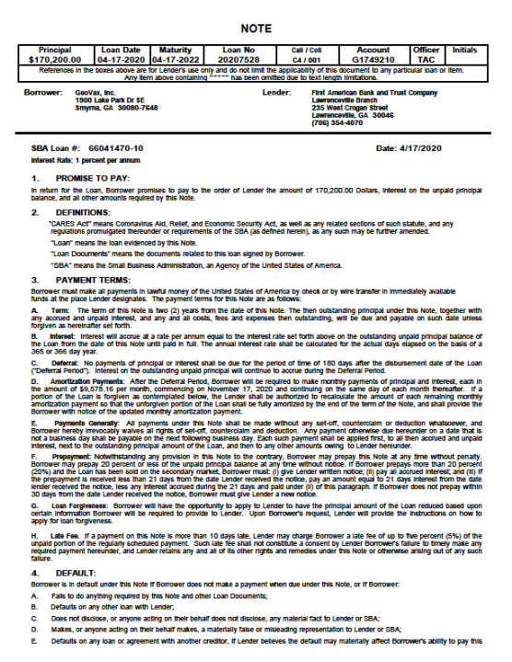

**Exhibit 10.1**





